**Acute Malnutrition |** November 2023 - October 2024

**Current Acute Malnutrition |** Month year - Month year

*Published on day Month, year*

**Projected Acute Malnutrition |** Month year - Month year

# 000,000

The number of 6-59 months children acutely malnourished

# 00,000

Number of pregnant or breastfeeding women acutely malnourished

Severe Acute Malnutrition (SAM)

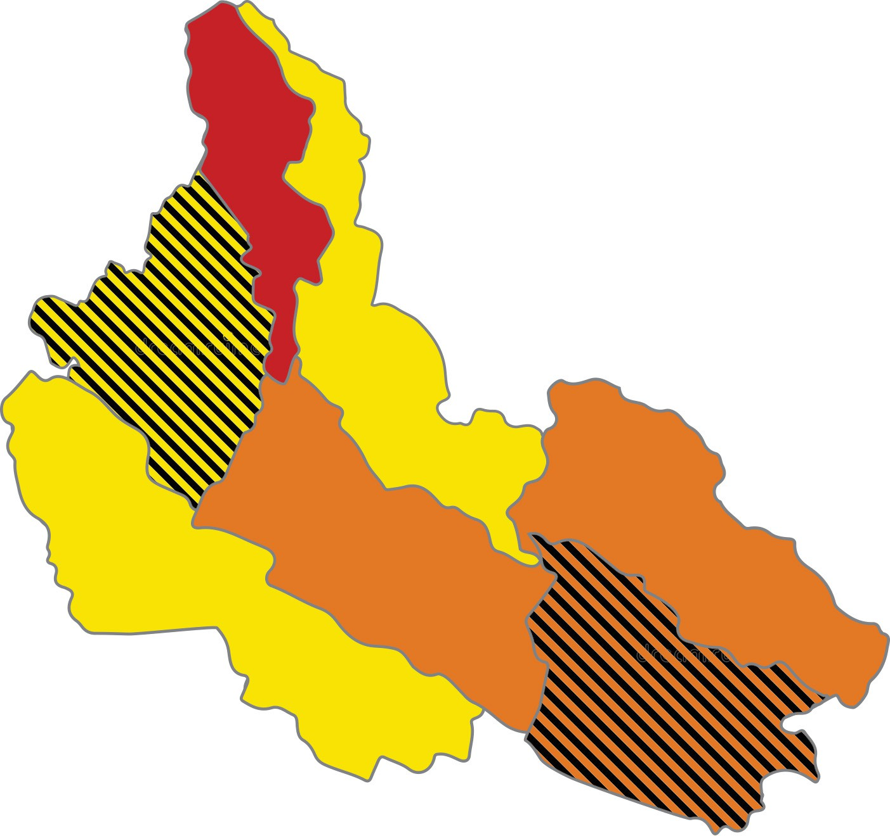

Image for illustration only.

**\*\*\***

Insert the IPC map in small size without details on area labels.

**\***

**\***

**\*\***

**\*\***

**Evidence Level**

**\*** Acceptable

**\*\*\*** High

**\*\*** Medium

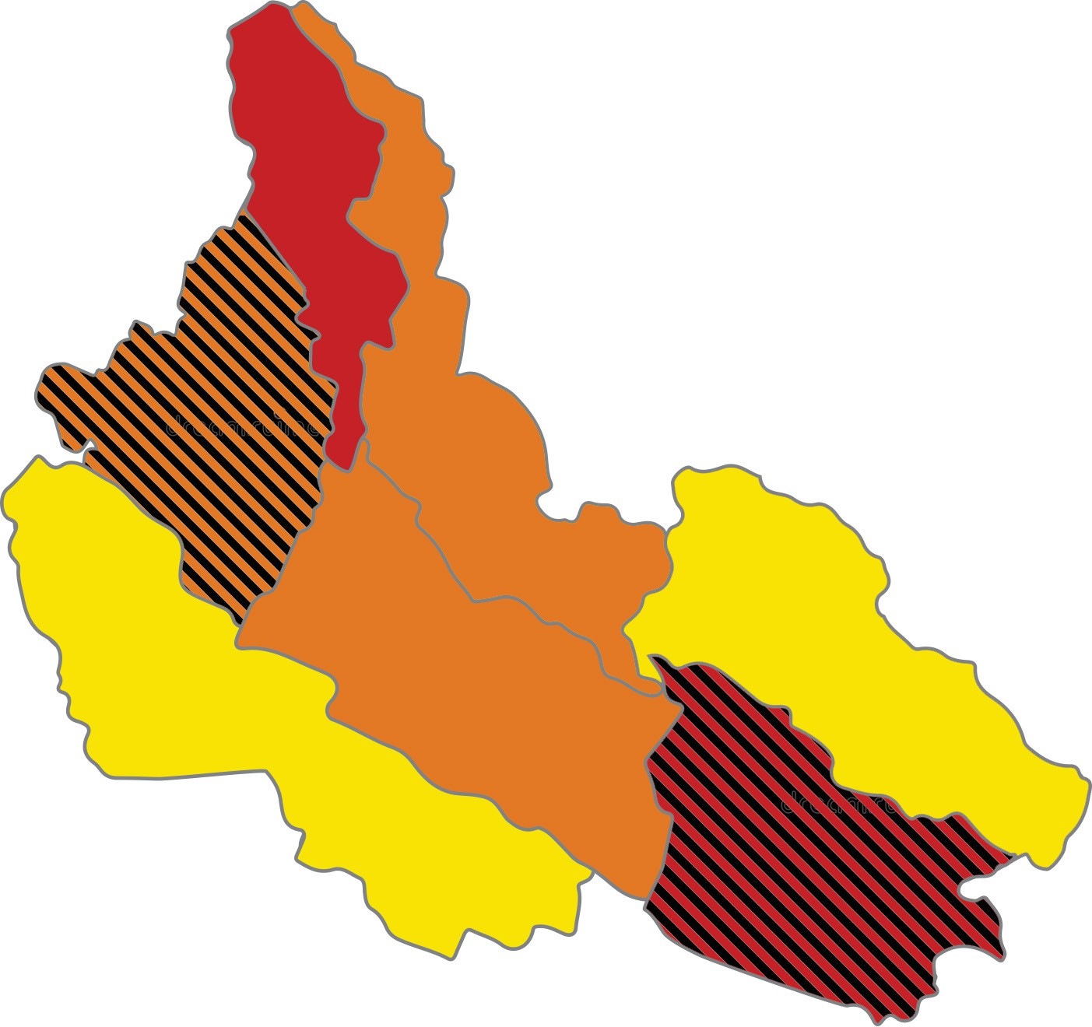

Image for illustration only.

**\*\*\***

Insert the IPC map in small size without details on area labels.

**\***

**\***

**\*\***

**\*\***

**Evidence Level**

**\*** Acceptable

**\*\*\*** High

**\*\*** Medium

00%

0.0M

Global Acute

Malnutrition

00%

Moderate Acute Malnutrition (MAM)

**Overview**

Limit overview text to 300 words. Font: 11/13 Myriad Pro light

Summarize the general acute malnutrition situation in the country, including the following aspects:

**How Severe, How Many and When:** the number of acutely malnourished children in the current period. Indicate how severe the situation is for the projected period. Estimates must be rounded up or down according to standard rounding rules and be consistent with the above table.

**Where:** the most affected areas and populations.

**Why:** the main factors driving the acute malnutrition situation.

Pa ditium ilit quodi simaior rovidel escipsum del experum commolorrum excea nissitam facipiciist porenit atiasse deria vel ma quam que culluptat fugia qui omnis sam, idunt dis molumquiam quature, inctur sum facepta vitem dit, sinci asperchicius rectati busa- perum que quae possit pror autam, utesedi apelitiati ius reptasp itatis ilis in nia in prae.

**Key for the Map**

IPC Acute Malnutrition Phase Classification

1. - Acceptable
2. - Alert
3. - Serious
4. - Critical
5. - Extremely critical

Phase classification based on MUAC

Areas with inadequate evidence



Areas not analysed

**Map Symbols**

Urban settlement classification

IDPs/other settlements classification

Scarce evidence due to limited or no humanitarian access

**Key for the Map**

IPC Acute Malnutrition Phase Classification

1. - Acceptable
2. - Alert
3. - Serious
4. - Critical
5. - Extremely critical

Phase classification based on MUAC

Areas with inadequate evidence



Areas not analysed

**Map Symbols**

Urban settlement classification

IDPs/other settlements classification

Scarce evidence due to limited or no humanitarian access

Us que elesedi int ped mo berum del eum inctia dolum sit dolupta perupta tissimporias ma quam, quas voloreh enimil min reribus ad eos enditat escimpo repero volora que nos sitatem id et autatemquam, necus, cum eos doloreped quiducitis ature ium est eaquoditatio et qui dessus.



**COUNTRY NAME:** IPC Acute Malnutrition Snapshot | Month year - Month year

Ci tem esequid ististe corentota venihilit fugit odit, tempere reprae cullab id quodi veliam, ut quas cusantium ra cullores quam volenda is aut omniasit eosanih itatur re- pudam, sum hiciliquia parciaecus sa perovit explaborro core ant pratatatur solor aliqua- tisci inverchil moditae por simint eum reprem. Alia voluptur, santis nectumque omnis resedi consent velicidel es untur?

Uga. Hent eatem doluptibus ute eliqui con con pa volupientius venda sequis earum res aut accus, quibuscillia dolupta temolupnet fugiandis doluptatur autatatatur, in con consed.Bitae nonet, od que nis dolectotae platiore eratectaque neseditat etus.

**IPC Analysis Partners**

Insert donor partner names associated with the country. Action Against Hunger, CARE, CILSS, EC-JRC, FAO, FEWS NET, Global Food Security Cluster, Global Nutrition Cluster, IFPRI, IGAD, Oxfam, SICA, SADC, Save the Children, UNDP, UNICEF, WFP, WHO and the World Bank.

Publication date: Month XX, year, *IPC population data is based on population estimates by Flowminder 2024. I Dis- claimer: The information shown on this map does not imply official recognition or endorsement of any physical and political boundaries. I For more information please contact [ipc@fao.org.](mailto:ipc@fao.org)

**Contributing Factors** (Myriad Pro Light 9/10 Blurbs - 50 words or less per factor)

**Contributing factor 1**

Insert a short description and icon for main factors contributing to acute malnutrition. Quo intio eum aliquiam nonsernam.

**Contributing factor 2**

Insert a short description and icon for main factors contributing to acute malnutrition. Hilitas re velesed min porum re, cuptatur re volut quo intio eum aliquiam nonsernam. Veremquate excea eos corati vendebissi nos repudiciendi dolor sit, voluptate vel earia doluptae occupientio. Dem que quis volentenim de quiscimint volorit ut acius dolor.

**Contributing factor 3**



Insert a short description and icon for main factors contributing to acute malnutrition. Intio eum aliquiam nonsernam. Pedisimo vel mod eos el esequam volluptia natur, ommo vollanit et quibus, expelenditas sinctat enimint que as exces.

**Contributing factor 4**



Insert a short description and icon for main factors contributing to acute malnutrition. Veremquate excea eos corati vendebissi nos repudiciendi dolor sit, voluptate vel earia doluptae occupientio. Dem que quis volentenim de quiscimint volorit ut acius dolor.

**Recommended Actions (**Limit text to 450 words. Font: 10/12 Myriad Pro light)

**Recommended action 1** ( Limit driver text to 50 words. Font: 9/11 Myriad Pro light )**.** Insert a short description and reccommended actions driving the food insecurity situation. Ab il inimus vid essus sandistibus, samus voluptae. Solora netur? Quiae modio repelitae plitae.



**Recommended action 2** ( Limit driver text to 50 words. Font: 9/11 Myriad Pro light )**.** Insert a short description and reccommended actions driving the food insecurity situation. Ab il inimus vid essus sandistibus, samus voluptae. Solora netur? Quiae modio repelitae plitae.

**Recommended action 3** ( Limit driver text to 50 words. Font: 9/11 Myriad Pro light )**.** Insert a short description and reccommended actions driving the food insecurity situation. Ab il inimus vid essus sandistibus, samus voluptae. Solora netur? Quiae modio repelitae plitae.

**Recommended action 4** ( Limit driver text to 50 words. Font: 9/11 Myriad Pro light )**.** Insert a short description and reccommended actions driving the food insecurity situation. Ab il inimus vid essus sandistibus, samus voluptae. Solora netur? Quiae modio repelitae plitae.

**Recommended action 5** ( Limit driver text to 50 words. Font: 9/11 Myriad Pro light ) Insert a short description and reccommended actions driving the food insecurity situation. Ab il inimus vid essus sandistibus, samus voluptae. Solora netur? Quiae modio repelitae plitae.

