 **Current Acute Food Insecurity |** Month year - Month year

00% of the population analysed in Region name are classified in Crisis or worse (IPC Phase 3 or above).

**Region Acute Food Insecurity Classification |** As of Month year

*Published on Day Month, year*

# 00.0M

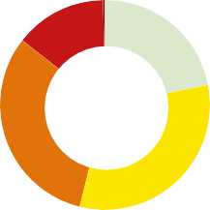

00% 00%

**00.0M**

Population

00% analysed

00%

Nearly 0.0 million people across Country are experiencing high levels of acute food insecurity (IPC Phase 3 or above) between Month and Month year. This including 000,000 people classified in Catastrophe (IPC Phase 5), meaning they have not received sufficient food assistance to prevent food consumption gaps.

**Regional Overview**

Limit overview text to 500 words. Font: 11/13 Myriad Pro light

1. - Minimal
2. - Stressed

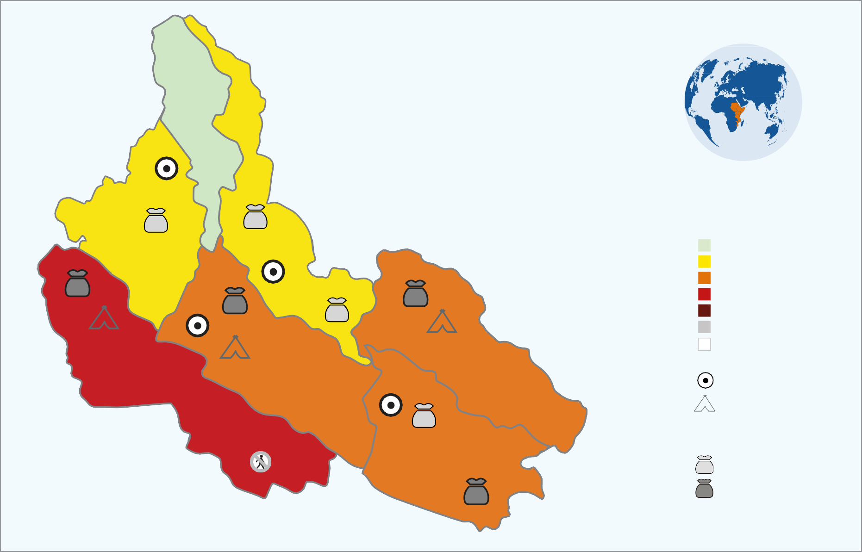

**\***

Image for illustration only.

Insert an IPC map of Regional area highlighting countries included in this snapshot.

Include a globe/map showing location of region.

**\*\***

**\*\***

**\*\*\***

**\*\*\***

**\*\*\***

**\*\*\***

**Evidence Level**

**Key for the Map**

**IPC Acute Food Insecurity Phase Classification**

1. - Minimal
2. - Stressed
3. - Crisis
4. - Emergency
5. - Famine

Areas with inadequate evidence Areas not analysed

**Map Symbols**

Urban settlement classification

IDPs/other settlements classification

**Area receives significant humanitarian food assistance** (accounted for in Phase classification)

* + 25% of households meet 25-50 of caloric needs through assistanc
  + 25% of households meet > 50 of caloric needs through assistan

**\*** Acceptable

**\*\*\*** High

**\*\*** Medium

1. - Crisis
2. - Emergency
3. - Famine

Summarize the general acute food insecurity situation in the region, including the following aspects:



**0.0M**



**0.0M**

**How severe, how many and when:** The number of people facing acute food insecurity in need of urgent action, how severe and for which period. Estimates must be rounded up or down according to standard rounding rules and be consistent with the above table.

**Where and who:** The most affected areas and populations.

**Why:** The main factors driving the current and projected acute food insecurity situation.

Puda sam fugitaspit es et est pratia custio odisto te peruptaque sit earum il incim quat opta ipissita sam quo inctemp orumquae. Si dipsunt iumendita autem haribus, que ipsunt ius quibus res rerum nusandi oditatempor sus eicium alic tem volenes namus ne pa peri sinctec tatiam et eumet arcium excea volorro que et laboria nisim num recus ella que num, coreserro voluptium reptati blaccabo. Bera quatur aut dolecto dolloribus ad quos apedit ut facest quunt, occumet re magnat et omni dolupta tiberferio tet pore, ommolenis ad quo beaquo ma quam volupta nitem fuga. Mo tem andigendi te doluptaquasi vendandem fuga. Edis repra velibus andunt enderia tatqui quia quissim ilique susdandicia sit endignatus, quibus etur, cus molupti que arci odit pedi temquidelent aut laborem nem nonsectus, niasin rero imendi officietur sinti aut eos am et eruptat.

Et volor sitempore latur aut officid magnitaerum essuntium numquisita quianis modi aut maio. Itatusa ndissundit facepuditaes ident quiamus qui net omnisquae natio m iur rerferiam eossunt qui beat audiost dolorruntur alitioria dolest venihit et, sitis eos aciissi consed quatibuscil ides dolo idissit facilliqui comnietur, sum voloria consectore essum volori tet liqui blam fugias nienditios es et doluptatquid qui rerspelecte pa qui non nullatequae ipsam eum hit, ipsuntibusa incte sa presciet optatem utas perovid ullique voluptat et acesci.

Bera quatur aut dolecto dolloribus ad quos apedit ut facest quunt, occumet re magnat et omni dolupta tiberferio tet pore, ommolenis ad quo beaquo ma quam volupta nitem fuga.

Bis eicilis qui acearibus rest, sus, et venda debitio di rem qui ilibusam quatem quati tem la nihilignam re que natiore vollab idi volupta temquo quidel ius unt harundis dollore nonsectia adit, unt apis dolutatibus aut quatusc iducia doluptatur sunt.

Omnis denis magnis illam, occumen diciis dolligenis que optam core eatibus, ullatem. Occum everchi cimolor estiatquo viducia verum reria nus dis dis as.

Puda sam fugitaspit es et est pratia custio odisto te peruptaque sit earum il incim quat opta ipissita sam quo inctemp orumquae. Si dipsunt iumendita autem haribus, que ipsunt ius quibus res rerum nusandi oditatempor sus eicium alic tem volenes namus ne pa peri coreserro voluptium reptati blaccabo. Bera quatur aut. sa ndissundit facepuditaes ident quiamus qui net omnisquae natio m iur rerferiam eossunt qui beat audiost dolorruntur alitioria dolest venihit et, sitis eos aciissi consed quatibuscil ides dolo idissit facilliqui comnietur, sum voloria consectore essum volori tet liqui blam fugias nienditios.

**Common Key Drivers** (Myriad Pro Light 9/10 Blurbs - 50 words or less per driver)

**Driver 1**

Insert a short description and icon for main factors driving the food insecurity situation. Nemperrorro di accusto ratur. Hilitas re velesed min porum re, cuptatur. Dem que quis volentenim de quiscimint volorit ut acius dolor. Omnist lam des ide et mod ma doles nonseces et quatiatat quo eosto quo eum sit pro apiendam, sus suntur, occumque.

**Driver 2**

Insert a short description and icon for main factors driving the food insecurity situation. Veremquate excea eos corati vendebissi nos repudiciendi dolor sit, voluptate vel earia doluptae occupientio. Dem que quis volentenim de quiscimint volorit ut aciusdolor. mnist lam des ide et mod ma doles nonseces et quatiatat quo eosto quo eum pro apiendam.

**Driver 3**

Insert a short description and icon for main factors driving the food insecurity situation. Veremquate excea eos corati vendebissi nos repudiciendi dolor sit, voluptate vel earia doluptae occupientio. Dem que quis volentenim de quiscimint volorit ut acius dolor. Omnist lam des ide et mod ma doles nonseces et quatiatat quo eosto quo eum sit am utaspit ist pro doluptet apiendam, sus suntur, occumque.

**Top Five Countries** hosting 00% of the population in Crisis or worse (IPC Phase 3 or above)

About 00 million (00%) of the people facing high levels of food insecurity in Crisis or worse (IPC Phase 3 or above) in this region are in Country, Country, Country, Country and Country.

Country Name



**0.0M**

Country Country

 Crisis  Emergency

Country Name



**00.0M**



**0.0M**

Country

**COUNTRY:** Current **|** Month year - Month year

**COUNTRY:** Current **|** Month year - Month year

**COUNTRY:** Current **|** Month year - Month year

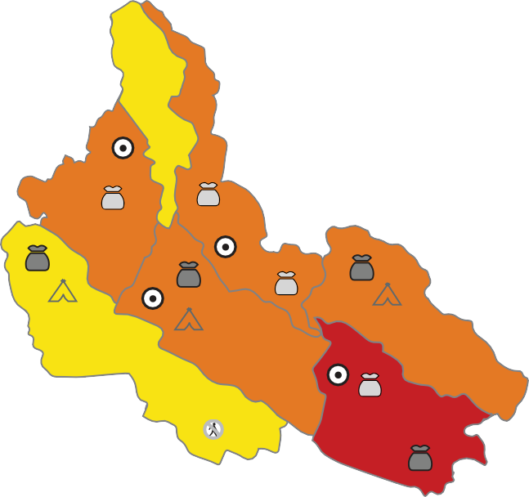

**\***

Image for illustration only.

Insert an IPC map of one of the countries in the regional area included in this snapshot.

**\*\***

Include a continent map to indicate where the country is located.

**\*\***

**\*\*\***

**\*\*\***

**\*\*\***

**\*\*\***

**Evidence Level**

**\*** Acceptable

**\*\*\*** High

**\*\*** Medium

**Key for the Map**

**IPC Acute Food Insecurity Phase Classification**

1. - Minimal
2. - Stressed
3. - Crisis
4. - Emergency
5. - Famine

Areas with inadequate evidence Areas not analysed

**Map Symbols**

Urban settlement classification

IDPs/other settlements classification

**Area receives significant humanitarian food assistance** (accounted for in Phase classification)

* + 25% of households meet 25-50% of caloric needs through assistance
  + 25% of households meet > 50% of caloric needs through assistance

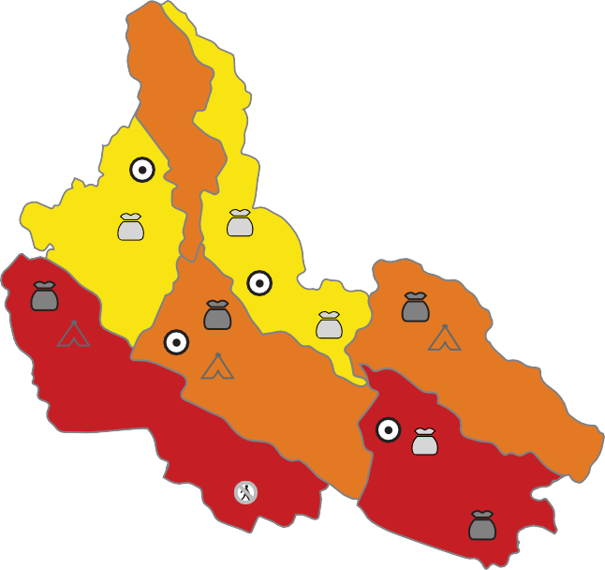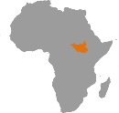

Image for illustration only.

Insert an IPC map of one of the

**\*\*\*** countries in the regional area

included in this snapshot.

**\*\***

Include a continent map to indicate where the country is located.

**\*\***

**\*\*\***

**\*\*\***

**\*\*\***

**\*\*\***

**Evidence Level**

**\*** Acceptable

**\*\*\*** High

**\*\*** Medium

**Key for the Map**

**IPC Acute Food Insecurity Phase Classification**

1. - Minimal
2. - Stressed
3. - Crisis
4. - Emergency
5. - Famine

Areas with inadequate evidence Areas not analysed

**Map Symbols**

Urban settlement classification

IDPs/other settlements classification

**Area receives significant humanitarian food assistance** (accounted for in Phase classification)

* + 25% of households meet 25-50% of caloric needs through assistance
  + 25% of households meet > 50% of caloric needs through assistance

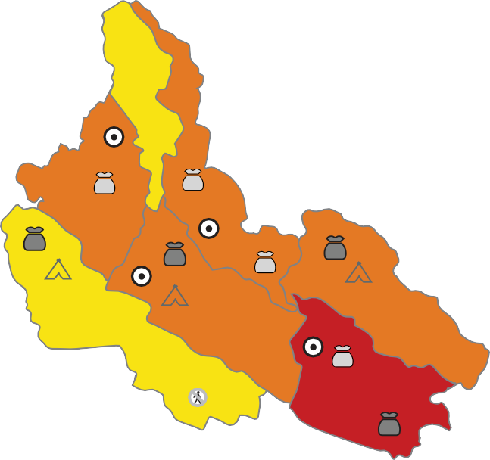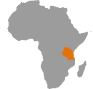

**\***

Image for illustration only.

Insert an IPC map of one of the countries in the regional area included in this snapshot.

**\*\***

Include a continent map to indicate where the country is located.

**\*\***

**\*\*\***

**\*\*\***

**\*\*\***

**\*\*\***

**Evidence Level**

**\*** Acceptable

**\*\*\*** High

**\*\*** Medium

**Key for the Map**

**IPC Acute Food Insecurity Phase Classification**

1. - Minimal
2. - Stressed
3. - Crisis
4. - Emergency
5. - Famine

Areas with inadequate evidence Areas not analysed

**Map Symbols**

Urban settlement classification

IDPs/other settlements classification

**Area receives significant humanitarian food assistance** (accounted for in Phase classification)

* + 25% of households meet 25-50% of caloric needs through assistance
  + 25% of households meet > 50% of caloric needs through assistance

**Current Acute Food Insecurity |** Month year - Month year

# 00.0 M

00% 00%

00%

**00.0M**

Population analysed

00%

00%

Nearly 0.0 million people across (Country) are experiencing high levels of acute food insecurity (IPC Phase 3 or above) between Month and Month year. This including 000,000 people classified in Catastrophe (IPC Phase 5), meaning they have not received sufficient food assistance to prevent food.

**Key Drivers**



1. - Minimal
2. - Stressed
3. - Crisis
4. - Emergency
5. - Famine

**Current Acute Food Insecurity |** Month year - Month year

# 00.0 M

00% 00%

00%

**00.0M**

Population analysed

00%

00%

Nearly 0.0 million people across (Country) are experiencing high levels of acute food insecurity (IPC Phase 3 or above) between Month and Month year. This including 000,000 people classified in Catastrophe (IPC Phase 5), meaning they have not received sufficient food assistance to prevent food.

**Key Drivers**



1. - Minimal
2. - Stressed
3. - Crisis
4. - Emergency
5. - Famine

**Current Acute Food Insecurity |** Month year - Month year

# 00.0 M

00% 00%

00%

**00.0M**

Population analysed

00%

00%

Nearly 0.0 million people across (Country) are experiencing high levels of acute food insecurity (IPC Phase 3 or above) between Month and Month year. This including 000,000 people classified in Catastrophe (IPC Phase 5), meaning they have not received sufficient food assistance to prevent food.

**Key Drivers**



1. - Minimal
2. - Stressed
3. - Crisis
4. - Emergency
5. - Famine

**Driver 1**

**Driver 2**

**Driver 3**

**Driver 1**

**Driver 2**

**Driver 3**

**Driver 1**

**Driver 2**

**Driver 3**

**Overview**

Limit overview text to 200 words. Font: 11/13 Myriad Pro light Summarize the current acute food insecurity situation in the country.

Et volor sitempore latur aut officid magnitaerum essuntium numquisita quianis modi aut maio. Itatusa ndissundit facepuditaes ident quiamus qui net omnisquae natio m iur rerferiam eossunt qui beat audiost dolorruntur alitioria dolest venihit et, sitis eos aciissi consed quatibuscil ides dolo idissit facilliqui comnietur, sum voloria consectore essum volori tet liqui blam fugias nienditios es et doluptatquid qui rerspelecte pa qui non nullatequae ipsam eum hit, ipsuntibusa incte sa presciet optatem utas perovid ullique voluptat et acesci.

Bera quatur aut dolecto dolloribus ad quos apedit ut facest quunt, occumet re magnat et omni dolupta tiberferio tet pore, ommolenis ad quo beaquo ma quam volupta nitem fuga.

Bis eicilis qui acearibus rest, sus, et venda debitio di rem qui ilibusam quatem quati tem la nihilignam re que natiore vollab idi volupta temquo quidel ius unt harundis dollore nonsectia adit, unt apis dolutatibus aut quatusc iducia doluptatur sunt.

**Overview**

Limit overview text to 200 words. Font: 11/13 Myriad Pro light Summarize the current acute food insecurity situation in the country.

Et volor sitempore latur aut officid magnitaerum essuntium numquisita quianis modi aut maio. Itatusa ndissundit facepuditaes ident quiamus qui net omnisquae natio m iur rerferiam eossunt qui beat audiost dolorruntur alitioria dolest venihit et, sitis eos aciissi consed quatibuscil ides dolo idissit facilliqui comnietur, sum voloria consectore essum volori tet liqui blam fugias nienditios es et doluptatquid qui rerspelecte pa qui non nullatequae ipsam eum hit, ipsuntibusa incte sa presciet optatem utas perovid ullique voluptat et acesci.

Bera quatur aut dolecto dolloribus ad quos apedit ut facest quunt, occumet re magnat et omni dolupta tiberferio tet pore, ommolenis ad quo beaquo ma quam volupta nitem fuga.

Bis eicilis qui acearibus rest, sus, et venda debitio di rem qui ilibusam quatem quati tem la nihilignam re que natiore vollab idi volupta temquo quidel ius unt harundis dollore nonsectia adit, unt apis dolutatibus aut quatusc iducia doluptatur sunt.

**Overview**

Limit overview text to 200 words. Font: 11/13 Myriad Pro light Summarize the current acute food insecurity situation in the country.

Et volor sitempore latur aut officid magnitaerum essuntium numquisita quianis modi aut maio. Itatusa ndissundit facepuditaes ident quiamus qui net omnisquae natio m iur rerferiam eossunt qui beat audiost dolorruntur alitioria dolest venihit et, sitis eos aciissi consed quatibuscil ides dolo idissit facilliqui comnietur, sum voloria consectore essum volori tet liqui blam fugias nienditios es et doluptatquid qui rerspelecte pa qui non nullatequae ipsam eum hit, ipsuntibusa incte sa presciet optatem utas perovid ullique voluptat et acesci.

Bera quatur aut dolecto dolloribus ad quos apedit ut facest quunt, occumet re magnat et omni dolupta tiberferio tet pore, ommolenis ad quo beaquo ma quam volupta nitem fuga.

Bis eicilis qui acearibus rest, sus, et venda debitio di rem qui ilibusam quatem quati tem la nihilignam re que natiore vollab idi volupta temquo quidel ius unt harundis dollore nonsectia adit, unt apis dolutatibus aut quatusc iducia doluptatur sunt.

**COUNTRY:** Current **|** Month year - Month year

**COUNTRY:** Current **|** Month year - Month year

**COUNTRY:** Current **|** Month year - Month year

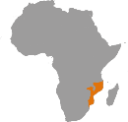

**\***

Image for illustration only.

Insert an IPC map of one of the countries in the regional area included in this snapshot.

**\*\***

Include a continent map to indicate where the country is located.

**\*\***

**\*\*\***

**\*\*\***

**\*\*\***

**\*\*\***

**Evidence Level**

**\*** Acceptable

**\*\*\*** High

**\*\*** Medium

**Key for the Map**

**IPC Acute Food Insecurity Phase Classification**

1. - Minimal
2. - Stressed
3. - Crisis
4. - Emergency
5. - Famine

Areas with inadequate evidence Areas not analysed

**Map Symbols**

Urban settlement classification

IDPs/other settlements classification

**Area receives significant humanitarian food assistance** (accounted for in Phase classification)

* + 25% of households meet 25-50% of caloric needs through assistance
  + 25% of households meet > 50% of caloric needs through assistance



Image for illustration only.

Insert an IPC map of one of the

**\*\*\*** countries in the regional area

included in this snapshot.

**\*\***

Include a continent map to indicate where the country is located.

**\*\***

**\*\*\***

**\*\*\***

**\*\*\***

**\*\*\***

**Evidence Level**

**\*** Acceptable

**\*\*\*** High

**\*\*** Medium

**Key for the Map**

**IPC Acute Food Insecurity Phase Classification**

1. - Minimal
2. - Stressed
3. - Crisis
4. - Emergency
5. - Famine

Areas with inadequate evidence Areas not analysed

**Map Symbols**

Urban settlement classification

IDPs/other settlements classification

**Area receives significant humanitarian food assistance** (accounted for in Phase classification)

* + 25% of households meet 25-50% of caloric needs through assistance
  + 25% of households meet > 50% of caloric needs through assistance

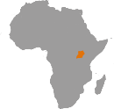

**\***

Image for illustration only.

Insert an IPC map of one of the countries in the regional area included in this snapshot.

**\*\***

Include a continent map to indicate where the country is located.

**\*\***

**\*\*\***

**\*\*\***

**\*\*\***

**\*\*\***

**Evidence Level**

**\*** Acceptable

**\*\*\*** High

**\*\*** Medium

**Key for the Map**

**IPC Acute Food Insecurity Phase Classification**

1. - Minimal
2. - Stressed
3. - Crisis
4. - Emergency
5. - Famine

Areas with inadequate evidence Areas not analysed

**Map Symbols**

Urban settlement classification

IDPs/other settlements classification

**Area receives significant humanitarian food assistance** (accounted for in Phase classification)

* + 25% of households meet 25-50% of caloric needs through assistance
  + 25% of households meet > 50% of caloric needs through assistance

**Current Acute Food Insecurity |** Month year - Month year

# 00.0 M

00% 00%

00%

**00.0M**

Population analysed

00%

00%

Nearly 0.0 million people across (Country) are experiencing high levels of acute food insecurity (IPC Phase 3 or above) between Month and Month year. This including 000,000 people classified in Catastrophe (IPC Phase 5), meaning they have not received sufficient food assistance to prevent food.

**Key Drivers**



1. - Minimal
2. - Stressed
3. - Crisis
4. - Emergency
5. - Famine

**Current Acute Food Insecurity |** Month year - Month year

# 00.0 M

00% 00%

00%

**00.0M**

Population analysed

00%

00%

Nearly 0.0 million people across (Country) are experiencing high levels of acute food insecurity (IPC Phase 3 or above) between Month and Month year. This including 000,000 people classified in Catastrophe (IPC Phase 5), meaning they have not received sufficient food assistance to prevent food.

**Key Drivers**



1. - Minimal
2. - Stressed
3. - Crisis
4. - Emergency
5. - Famine

**Current Acute Food Insecurity |** Month year - Month year

# 00.0 M

00% 00%

00%

**00.0M**

Population analysed

00%

00%

Nearly 0.0 million people across (Country) are experiencing high levels of acute food insecurity (IPC Phase 3 or above) between Month and Month year. This including 000,000 people classified in Catastrophe (IPC Phase 5), meaning they have not received sufficient food assistance to prevent food.

**Key Drivers**



1. - Minimal
2. - Stressed
3. - Crisis
4. - Emergency
5. - Famine

**Driver 1**

**Driver 2**

**Driver 3**

**Driver 1**

**Driver 2**

**Driver 3**

**Driver 1**

**Driver 2**

**Driver 3**

**Overview**

Limit overview text to 200 words. Font: 11/13 Myriad Pro light Summarize the current acute food insecurity situation in the country.

Et volor sitempore latur aut officid magnitaerum essuntium numquisita quianis modi aut maio. Itatusa ndissundit facepuditaes ident quiamus qui net omnisquae natio m iur rerferiam eossunt qui beat audiost dolorruntur alitioria dolest venihit et, sitis eos aciissi consed quatibuscil ides dolo idissit facilliqui comnietur, sum voloria consectore essum volori tet liqui blam fugias nienditios es et doluptatquid qui rerspelecte pa qui non nullatequae ipsam eum hit, ipsuntibusa incte sa presciet optatem utas perovid ullique voluptat et acesci.

Bera quatur aut dolecto dolloribus ad quos apedit ut facest quunt, occumet re magnat et omni dolupta tiberferio tet pore, ommolenis ad quo beaquo ma quam volupta nitem fuga.

Bis eicilis qui acearibus rest, sus, et venda debitio di rem qui ilibusam quatem quati tem la nihilignam re que natiore vollab idi volupta temquo quidel ius unt harundis dollore nonsectia adit, unt apis dolutatibus aut quatusc iducia doluptatur sunt.

**Overview**

Limit overview text to 200 words. Font: 11/13 Myriad Pro light Summarize the current acute food insecurity situation in the country.

Et volor sitempore latur aut officid magnitaerum essuntium numquisita quianis modi aut maio. Itatusa ndissundit facepuditaes ident quiamus qui net omnisquae natio m iur rerferiam eossunt qui beat audiost dolorruntur alitioria dolest venihit et, sitis eos aciissi consed quatibuscil ides dolo idissit facilliqui comnietur, sum voloria consectore essum volori tet liqui blam fugias nienditios es et doluptatquid qui rerspelecte pa qui non nullatequae ipsam eum hit, ipsuntibusa incte sa presciet optatem utas perovid ullique voluptat et acesci.

Bera quatur aut dolecto dolloribus ad quos apedit ut facest quunt, occumet re magnat et omni dolupta tiberferio tet pore, ommolenis ad quo beaquo ma quam volupta nitem fuga.

Bis eicilis qui acearibus rest, sus, et venda debitio di rem qui ilibusam quatem quati tem la nihilignam re que natiore vollab idi volupta temquo quidel ius unt harundis dollore nonsectia adit, unt apis dolutatibus aut quatusc iducia doluptatur sunt.

**Overview**

Limit overview text to 200 words. Font: 11/13 Myriad Pro light Summarize the current acute food insecurity situation in the country.

Et volor sitempore latur aut officid magnitaerum essuntium numquisita quianis modi aut maio. Itatusa ndissundit facepuditaes ident quiamus qui net omnisquae natio m iur rerferiam eossunt qui beat audiost dolorruntur alitioria dolest venihit et, sitis eos aciissi consed quatibuscil ides dolo idissit facilliqui comnietur, sum voloria consectore essum volori tet liqui blam fugias nienditios es et doluptatquid qui rerspelecte pa qui non nullatequae ipsam eum hit, ipsuntibusa incte sa presciet optatem utas perovid ullique voluptat et acesci.

Bera quatur aut dolecto dolloribus ad quos apedit ut facest quunt, occumet re magnat et omni dolupta tiberferio tet pore, ommolenis ad quo beaquo ma quam volupta nitem fuga.

Bis eicilis qui acearibus rest, sus, et venda debitio di rem qui ilibusam quatem quati tem la nihilignam re que natiore vollab idi volupta temquo quidel ius unt harundis dollore nonsectia adit, unt apis dolutatibus aut quatusc iducia doluptatur sunt.

**COUNTRY:** Projected **|** Month year - Month year

**COUNTRY:** Projected **|** Month year - Month year

**COUNTRY:** Projected **|** Month year - Month year

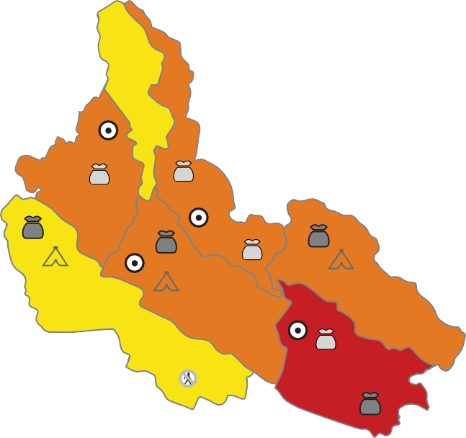

**\***

Image for illustration only.

Insert an IPC map of one of the countries in the regional area included in this snapshot.

**\*\***

Include a continent map to indicate where the country is located.

**\*\***

**\*\*\***

**\*\*\***

**\*\*\***

**Key for the Map**

**IPC Acute Food Insecurity Phase Classification**

1. - Minimal
2. - Stressed
3. - Crisis
4. - Emergency
5. - Famine

Areas with inadequate evidence Areas not analysed

**Map Symbols**

Urban settlement classification

IDPs/other settlements classification

**\*\*\***

**Evidence Level**

**\*** Acceptable

**\*\*\*** High

**\*\*** Medium

**Area receives significant humanitarian food assistance** (accounted for in Phase classification)

* 25% of households meet 25-50% of caloric needs through assistance
* 25% of households meet > 50% of caloric needs through assistance

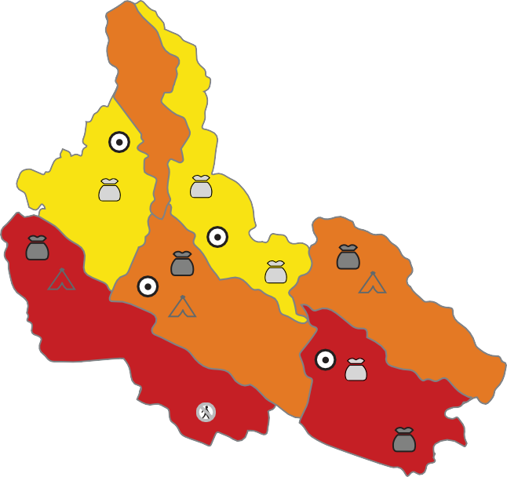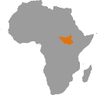

Image for illustration only.

Insert an IPC map of one of the

**\*\*\*** countries in the regional area

included in this snapshot.

**\*\***

Include a continent map to indicate where the country is located.

**\*\***

**\*\*\***

**\*\*\***

**\*\*\***

**Key for the Map**

**IPC Acute Food Insecurity Phase Classification**

1. - Minimal
2. - Stressed
3. - Crisis
4. - Emergency
5. - Famine

Areas with inadequate evidence Areas not analysed

**Map Symbols**

Urban settlement classification

IDPs/other settlements classification

**\*\*\***

**Evidence Level**

**\*** Acceptable

**\*\*\*** High

**\*\*** Medium

**Area receives significant humanitarian food assistance** (accounted for in Phase classification)

* 25% of households meet 25-50% of caloric needs through assistance
* 25% of households meet > 50% of caloric needs through assistance

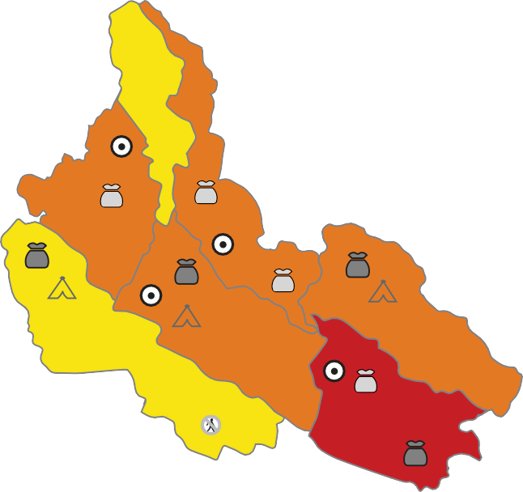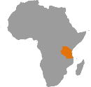

**\***

Image for illustration only.

Insert an IPC map of one of the countries in the regional area included in this snapshot.

**\*\***

Include a continent map to indicate where the country is located.

**\*\***

**\*\*\***

**\*\*\***

**\*\*\***

**\*\*\***

**Evidence Level**

**\*** Acceptable

**\*\*\*** High

**\*\*** Medium

**Key for the Map**

**IPC Acute Food Insecurity Phase Classification**

1. - Minimal
2. - Stressed
3. - Crisis
4. - Emergency
5. - Famine

Areas with inadequate evidence Areas not analysed

**Map Symbols**

Urban settlement classification

IDPs/other settlements classification

**Area receives significant humanitarian food assistance** (accounted for in Phase classification)

* + 25% of households meet 25-50% of caloric needs through assistance
  + 25% of households meet > 50% of caloric needs through assistance

**Projected Acute Food Insecurity |** Month year - Month year

# 00.0 M

00% 00%

00%

**00.0M**

Population analysed

00%

00%

Approximately 0.0 million people across (Country) will likely experience high levels of acute food insecurity (IPC Phase 3 or above) between

Month year - Month year.

1. - Minimal
2. - Stressed
3. - Crisis
4. - Emergency
5. - Famine

**Projected Acute Food Insecurity |** Month year - Month year

# 00.0 M

00% 00%

00%

**00.0M**

Population analysed

00%

00%

Approximately 0.0 million people across (Country) will likely experience high levels of acute food insecurity (IPC Phase 3 or above) between

Month year - Month year.

1. - Minimal
2. - Stressed
3. - Crisis
4. - Emergency
5. - Famine

**Projected Acute Food Insecurity |** Month year - Month year

# 00.0 M

00% 00%

00%

**00.0M**

Population analysed

00%

00%

Approximately 0.0 million people across (Country) will likely experience high levels of acute food insecurity (IPC Phase 3 or above) between

Month year - Month year.

1. - Minimal
2. - Stressed
3. - Crisis
4. - Emergency
5. - Famine

**Key Drivers**

**Driver 1**

**Driver 2**

**Driver 3**

**Key Drivers**

**Driver 1**

**Driver 2**

**Driver 3**

**Key Drivers**

**Driver 1**

**Driver 2**

**Driver 3**

**Overview**



Limit overview text to 200 words. Font: 11/13 Myriad Pro light Summarize the projected acute food insecurity situation in the country.

Et volor sitempore latur aut officid magnitaerum essuntium numquisita quianis modi aut maio. Itatusa ndissundit facepuditaes ident quiamus qui net omnisquae natio m iur rerferiam eossunt qui beat audiost dolorruntur alitioria dolest venihit et, sitis eos aciissi consed quatibuscil ides dolo idissit facilliqui comnietur, sum voloria consectore essum volori tet liqui blam fugias nienditios es et doluptatquid qui rerspelecte pa qui non nullatequae ipsam eum hit, ipsuntibusa incte sa presciet optatem utas perovid ullique voluptat et acesci.

Bera quatur aut dolecto dolloribus ad quos apedit ut facest quunt, occumet re magnat et omni dolupta tiberferio tet pore, ommolenis ad quo beaquo ma quam volupta nitem fuga.

Bis eicilis qui acearibus rest, sus, et venda debitio di rem qui ilibusam quatem quati tem la nihilignam re que natiore vollab idi volupta temquo quidel ius unt harundis dollore nonsectia adit, unt apis dolutatibus aut quatusc iducia doluptatur sunt.

**Overview**

Limit overview text to 200 words. Font: 11/13 Myriad Pro light Summarize the projected acute food insecurity situation in the country.

Et volor sitempore latur aut officid magnitaerum essuntium numquisita quianis modi aut maio. Itatusa ndissundit facepuditaes ident quiamus qui net omnisquae natio m iur rerferiam eossunt qui beat audiost dolorruntur alitioria dolest venihit et, sitis eos aciissi consed quatibuscil ides dolo idissit facilliqui comnietur, sum voloria consectore essum volori tet liqui blam fugias nienditios es et doluptatquid qui rerspelecte pa qui non nullatequae ipsam eum hit, ipsuntibusa incte sa presciet optatem utas perovid ullique voluptat et acesci.

Bera quatur aut dolecto dolloribus ad quos apedit ut facest quunt, occumet re magnat et omni dolupta tiberferio tet pore, ommolenis ad quo beaquo ma quam volupta nitem fuga.

Bis eicilis qui acearibus rest, sus, et venda debitio di rem qui ilibusam quatem quati tem la nihilignam re que natiore vollab idi volupta temquo quidel ius unt harundis dollore nonsectia adit, unt apis dolutatibus aut quatusc iducia doluptatur sunt.

**Overview**

Limit overview text to 200 words. Font: 11/13 Myriad Pro light Summarize the projected acute food insecurity situation in the country.

Et volor sitempore latur aut officid magnitaerum essuntium numquisita quianis modi aut maio. Itatusa ndissundit facepuditaes ident quiamus qui net omnisquae natio m iur rerferiam eossunt qui beat audiost dolorruntur alitioria dolest venihit et, sitis eos aciissi consed quatibuscil ides dolo idissit facilliqui comnietur, sum voloria consectore essum volori tet liqui blam fugias nienditios es et doluptatquid qui rerspelecte pa qui non nullatequae ipsam eum hit, ipsuntibusa incte sa presciet optatem utas perovid ullique voluptat et acesci.

Bera quatur aut dolecto dolloribus ad quos apedit ut facest quunt, occumet re magnat et omni dolupta tiberferio tet pore, ommolenis ad quo beaquo ma quam volupta nitem fuga.

Bis eicilis qui acearibus rest, sus, et venda debitio di rem qui ilibusam quatem quati tem la nihilignam re que natiore vollab idi volupta temquo quidel ius unt harundis dollore nonsectia adit, unt apis dolutatibus aut quatusc iducia doluptatur sunt.

**COUNTRY:** Projected **|** Month year - Month year

**COUNTRY:** Projected **|** Month year - Month year

**COUNTRY:** Projected **|** Month year - Month year

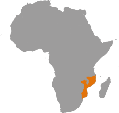

**\***

Image for illustration only.

Insert an IPC map of one of the countries in the regional area included in this snapshot.

**\*\***

Include a continent map to indicate where the country is located.

**\*\***

**\*\*\***

**\*\*\***

**\*\*\***

**Key for the Map**

**IPC Acute Food Insecurity Phase Classification**

1. - Minimal
2. - Stressed
3. - Crisis
4. - Emergency
5. - Famine

Areas with inadequate evidence Areas not analysed

**Map Symbols**

Urban settlement classification

IDPs/other settlements classification

**\*\*\***

**Evidence Level**

**\*** Acceptable

**\*\*\*** High

**\*\*** Medium

**Area receives significant humanitarian food assistance** (accounted for in Phase classification)

* 25% of households meet 25-50% of caloric needs through assistance
* 25% of households meet > 50% of caloric needs through assistance



Image for illustration only.

Insert an IPC map of one of the

**\*\*\*** countries in the regional area

included in this snapshot.

**\*\***

Include a continent map to indicate where the country is located.

**\*\***

**\*\*\***

**\*\*\***

**\*\*\***

**Key for the Map**

**IPC Acute Food Insecurity Phase Classification**

1. - Minimal
2. - Stressed
3. - Crisis
4. - Emergency
5. - Famine

Areas with inadequate evidence Areas not analysed

**Map Symbols**

Urban settlement classification

IDPs/other settlements classification

**\*\*\***

**Evidence Level**

**\*** Acceptable

**\*\*\*** High

**\*\*** Medium

**Area receives significant humanitarian food assistance** (accounted for in Phase classification)

* 25% of households meet 25-50% of caloric needs through assistance
* 25% of households meet > 50% of caloric needs through assistance

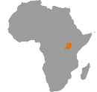

**\***

Image for illustration only.

Insert an IPC map of one of the countries in the regional area included in this snapshot.

**\*\***

Include a continent map to indicate where the country is located.

**\*\***

**\*\*\***

**\*\*\***

**\*\*\***

**\*\*\***

**Evidence Level**

**\*** Acceptable

**\*\*\*** High

**\*\*** Medium

**Key for the Map**

**IPC Acute Food Insecurity Phase Classification**

1. - Minimal
2. - Stressed
3. - Crisis
4. - Emergency
5. - Famine

Areas with inadequate evidence Areas not analysed

**Map Symbols**

Urban settlement classification

IDPs/other settlements classification

**Area receives significant humanitarian food assistance** (accounted for in Phase classification)

* + 25% of households meet 25-50% of caloric needs through assistance
  + 25% of households meet > 50% of caloric needs through assistance

**Projected Acute Food Insecurity |** Month year - Month year

# 00.0 M

00% 00%

00%

**00.0M**

Population analysed

00%

00%

Approximately 0.0 million people across (Country) will likely experience high levels of acute food insecurity (IPC Phase 3 or above) between

Month year - Month year.

1. - Minimal
2. - Stressed
3. - Crisis
4. - Emergency
5. - Famine

**Projected Acute Food Insecurity |** Month year - Month year

# 00.0 M

00% 00%

00%

**00.0M**

Population analysed

00%

00%

Approximately 0.0 million people across (Country) will likely experience high levels of acute food insecurity (IPC Phase 3 or above) between

Month year - Month year.

1. - Minimal
2. - Stressed
3. - Crisis
4. - Emergency
5. - Famine

**Projected Acute Food Insecurity |** Month year - Month year

# 00.0 M

00% 00%

00%

**00.0M**

Population analysed

00%

00%

Approximately 0.0 million people across (Country) will likely experience high levels of acute food insecurity (IPC Phase 3 or above) between

Month year - Month year.

1. - Minimal
2. - Stressed
3. - Crisis
4. - Emergency
5. - Famine

**Key Drivers**

**Driver 1**

**Driver 2**

**Driver 3**

**Key Drivers**

**Driver 1**

**Driver 2**

**Driver 3**

**Key Drivers**

**Driver 1**

**Driver 2**

**Driver 3**

**Overview**



Limit overview text to 200 words. Font: 11/13 Myriad Pro light Summarize the projected acute food insecurity situation in the country.

Et volor sitempore latur aut officid magnitaerum essuntium numquisita quianis modi aut maio. Itatusa ndissundit facepuditaes ident quiamus qui net omnisquae natio m iur rerferiam eossunt qui beat audiost dolorruntur alitioria dolest venihit et, sitis eos aciissi consed quatibuscil ides dolo idissit facilliqui comnietur, sum voloria consectore essum volori tet liqui blam fugias nienditios es et doluptatquid qui rerspelecte pa qui non nullatequae ipsam eum hit, ipsuntibusa incte sa presciet optatem utas perovid ullique voluptat et acesci.

Bera quatur aut dolecto dolloribus ad quos apedit ut facest quunt, occumet re magnat et omni dolupta tiberferio tet pore, ommolenis ad quo beaquo ma quam volupta nitem fuga.

Bis eicilis qui acearibus rest, sus, et venda debitio di rem qui ilibusam quatem quati tem la nihilignam re que natiore vollab idi volupta temquo quidel ius unt harundis dollore nonsectia adit, unt apis dolutatibus aut quatusc iducia doluptatur sunt.

**Overview**

Limit overview text to 200 words. Font: 11/13 Myriad Pro light Summarize the projected acute food insecurity situation in the country.

Et volor sitempore latur aut officid magnitaerum essuntium numquisita quianis modi aut maio. Itatusa ndissundit facepuditaes ident quiamus qui net omnisquae natio m iur rerferiam eossunt qui beat audiost dolorruntur alitioria dolest venihit et, sitis eos aciissi consed quatibuscil ides dolo idissit facilliqui comnietur, sum voloria consectore essum volori tet liqui blam fugias nienditios es et doluptatquid qui rerspelecte pa qui non nullatequae ipsam eum hit, ipsuntibusa incte sa presciet optatem utas perovid ullique voluptat et acesci.

Bera quatur aut dolecto dolloribus ad quos apedit ut facest quunt, occumet re magnat et omni dolupta tiberferio tet pore, ommolenis ad quo beaquo ma quam volupta nitem fuga.

Bis eicilis qui acearibus rest, sus, et venda debitio di rem qui ilibusam quatem quati tem la nihilignam re que natiore vollab idi volupta temquo quidel ius unt harundis dollore nonsectia adit, unt apis dolutatibus aut quatusc iducia doluptatur sunt.

**Overview**

Limit overview text to 200 words. Font: 11/13 Myriad Pro light Summarize the projected acute food insecurity situation in the country.

Et volor sitempore latur aut officid magnitaerum essuntium numquisita quianis modi aut maio. Itatusa ndissundit facepuditaes ident quiamus qui net omnisquae natio m iur rerferiam eossunt qui beat audiost dolorruntur alitioria dolest venihit et, sitis eos aciissi consed quatibuscil ides dolo idissit facilliqui comnietur, sum voloria consectore essum volori tet liqui blam fugias nienditios es et doluptatquid qui rerspelecte pa qui non nullatequae ipsam eum hit, ipsuntibusa incte sa presciet optatem utas perovid ullique voluptat et acesci.

Bera quatur aut dolecto dolloribus ad quos apedit ut facest quunt, occumet re magnat et omni dolupta tiberferio tet pore, ommolenis ad quo beaquo ma quam volupta nitem fuga.

Bis eicilis qui acearibus rest, sus, et venda debitio di rem qui ilibusam quatem quati tem la nihilignam re que natiore vollab idi volupta temquo quidel ius unt harundis dollore nonsectia adit, unt apis dolutatibus aut quatusc iducia doluptatur sunt.

**The IPC and (name of region)**

Limit overview text to 800 words. Font: 11/13 Myriad Pro light

Ere nempore ndigniendam facia dolorem olorro offic to doloratum re, im quatiae ne neceaquam id mostis rerionecat doloratur?

Sae. Et quam dollect aecatust, tempore prorem ipient labore nis inctatur? Aqui ut aliquib ustiandit acea simagni hillant rae cument, vel ium secum voluptam eum, utat ad ut omnis aut restrumet apel eius, tem ide pa nonsed minulla ccuptatur re pro comnis alit autempe rumquiatur? Quia nam ullesto et officimusam nobit ex eum que lam verunt.

Maionsequam re duciam eos exeri verianimaio. Hilitin rescipsam fugiat ent experianim eicatquam utatquibus, quost dolupid quia is eicidelit dio mossit, to ipsundebis plis eaquas doluptaquia pa debisimos ipsum laccae aut dolum sequis mosant hillitatiuri dolore, nia consequidus nos dunt aliam faccusdae ipsunt, optati aut volorit ut disinul laborro maios peribus andipit venima seque ressum fugitatibusa autestiandes eat.

Usant. Derchit qui ommolorem restio. Ga. Nam quiam as delicia nimaio comnissit et, soluptatet estem sitam quis et reptae. Aquiae laccus, ventus.

Torectotae delloresciis simpore strunt omnimag natquam vel il ilit omnient earum nam inctotatur?

Ro comnit doloratur sitia dolupta temolenimus volectas dolorest, cum fugiae. Nam et et voluptati tem etur magnis sed que parum ra debitam, sundion eaquatu sapidus eostem volora sectatu ritiore ea alit fugiae re pellab illendel id quam id molendit experciet milique expedit fuga. Nus, cus etur?

Te sunte et in re essit utatur? Quis nonsequi is susapicimin restorehento iduciis rere re di voluptur soluptas et que liqui dolore versperum, quodi vita doluptatur mo odi conessi nciam, commos sit el molestrunt utem inctat verorum abo. Ad qui dolut fugita eum dernatis molores ipsunt quam etur seque volumenimet eum re cum fugit, necaes quo odia apic testrum sapelesto ma quate sundi qui odit estecea rciatur? Quid quati dolor si re net alit, officaero tet dus sant, simi, sitatio. Enditam quam volecti ad ulpa nobis poruntotatem delitatus, cus aliqui dem aces renda dolendem expedig enditatem eturiorrum nosa volor aut omnihicatati int, nem volecte omnis rernatur mo omnitas abo. Os et expediti quatiossunt ut ad quo eictotatur, conseque rate que voluptatis aut officia volendis sunt.

Illab imil millorest, sa nam, to volum qui voluptatur atis eum aut perum alitiaest reptur ad explit maio cus, comnient aut et ex es quiduntiaest que vel ides aut accusci te qui apis ese dit ut inulluptatis et aut ut landita et et eicab in custem adi sanimil ipsaeperit ullaborias cone con rem et ilic totatur recat quatquamus exceptatis ipid quos sequae non ratisqui dolupta tenias eum landani squiat quibus, et fuga. Gentem. Qui ant facculp archicit autes maionsequi aspercil ea porerib uscius.

Mi, vid quasperum eatia peliquia di cuptaquas es alit alique pos debisim osamus. Ibus vere, omniet quodit dolorite nonseriamus, ut apitis cor aditat.

Simi, sus et acepell uptati delecto beaturehent.

Soles adit est venihic to eturese quibus, sam il miniendae dolo quam facerci endamusam, optis re que minvern atatet hillaborit modipidus.

Elita nonsecto doles quiatet autat.

Non restia perro totas deliquam eri nonse laut que con nonet, untectemqui nonsequati quos magnis etum aut quodi conecusape voluptatem dolent, odiorem aligendio blabor aute neceseq uamenda vendips undandit, cuptat eatur acersped magnihi ligenda dem sustora nonse pelit quos acea nia volorib eatium a int rerio tem labor aut eatur seque vent.

Ro comnit doloratur sitia dolupta temolenimus volectas dolorest, cum fugiae. Nam et et voluptati tem etur magnis sed que parum ra debitam, sundion eaquatu sapidus eostem volora sectatu ritiore ea alit fugiae re pellab illendel id quam id molendit experciet milique expedit fuga. Nus, cus etur?

Te sunte et in re essit utatur? Quis nonsequi is susapicimin restorehento iduciis rere re di voluptur soluptas et que liqui dolore versperum, quodi vita doluptatur mo odi conessi nciam, commos sit el molestrunt utem inctat verorum abo. Ad qui dolut fugita eum dernatis molores ipsunt quam etur seque volumenimet eum re cum fugit, necaes quo odia apic testrum sapelesto ma quate sundi qui odit estecea rciatur? Quid quati dolor si re net alit, officaero tet dus sant, simi, sitatio. Enditam quam volecti ad ulpa nobis poruntotatem delitatus, cus aliqui dem aces renda dolendem expedig enditatem eturiorrum nosa volor aut omnihicatati int, nem volecte omnis rernatur mo omnitas abo. Os et expediti quatiossunt ut ad quo eictotatur, conseque rate que voluptatis aut officia volendis sunt.

Illab imil millorest, sa nam, to volum qui voluptatur atis eum aut perum alitiaest reptur ad explit maio cus, comnient aut et ex es quiduntiaest que vel ides aut accusci te qui apis ese dit ut inulluptatis et aut ut landita et et eicab in custem adi sanimil ipsaeperit ullaborias cone con rem et ilic totatur recat quatquamus exceptatis ipid quos sequae non ratisqui dolupta tenias eum landani squiat quibus, et fuga. Gentem. Qui ant facculp archicit autes maionsequi aspercil ea porerib uscius.

Mi, vid quasperum eatia peliquia di cuptaquas es alit alique pos debisim osamus. Ibus vere, omniet quodit dolorite nonseriamus, ut apitis cor aditat.

Simi, sus et acepell uptati delecto beaturehent.

Soles adit est venihic to eturese quibus, sam il miniendae dolo quam facerci endamusam, optis re que minvern atatet hillaborit modipidus.

**IPC Analysis Partners**

Insert donor partner logos

**About the IPC and Acute Food Insecurity**

The IPC is a set of tools and procedures to classify the severity and characteristics of acute food and nutrition crises as well as chronic food insecurity based on international standards. The IPC consists of four mutually reinforcing functions, each with a set of specific protocols (tools and procedures).

The core IPC parameters include consensus building, convergence of evidence, accountability, transparency and comparability. The IPC analysis aims at informing emergency response as well as medium and long-term food security policy and programming.

For the IPC, Acute Food Insecurity is defined as any manifestation of food insecurity found in a specified area at a specific point in time of a severity that threatens lives or livelihoods, or both, regardless of the causes, context or duration. It is highly susceptible to change and can occur and manifest in a population within a short amount of time, as a result of sudden changes or shocks that negatively impact the drivers of food insecurity.

**About the IPC Acute Food Insecurity Scale**

The IPC Acute Food Insecurity scale has become the global standard for the classification of acute food insecurity. It is used principally to inform decisions on resource allocation and programming globally and within countries, especially for countries experiencing recurrent or protracted food crises.

|  |  |  |  |  |
| --- | --- | --- | --- | --- |
| **Phase 1 None/Minimal** | **Phase 2 Stressed** | **Phase 3 Crisis** | **Phase 4 Emergency** | **Phase 5 Catastrophe/ Famine** |
| Households are able to meet essential food and non-food needs without engaging in atypical and unsustainable strategies to access food and income. | Households have minimally adequate food consumption but are unable to afford some essential non- food expenditures without engaging  in stress-coping strategies. | Households either:   * have food consumption gaps that are reflected by high or above-usual acute malnutrition; **or** * are marginally able to meet minimum food needs but only by depleting essential livelihood assets or through crisis-coping strategies. | Households either:   * have large food consumption gaps that are reflected in very high acute malnutrition and excess mortality; **or** * are able to mitigate large food consumption gaps   but only by employing emergency livelihood strategies and asset liquidation | Households have an extreme lack of food and/ or are unable to meet other basic needs even after full employment  of coping strategies. Starvation, death, destitution and extremely critical acute malnutrition levels are evident.  (For Famine classification, an area needs to have extreme critical levels of acute malnutrition and mortality.) |

For more information, please contact the IPC at [ipc@fao.org](mailto:ipc@fao.org) or the IPC Regional Coordinator for (Region), Name at [email@fao.org](mailto:email@fao.org)

Publication date: Day Month, year.* Population data is based on (source, year). Disclaimer: The information on this map does not imply official recogni- tion or endorsement of any physical and political boundaries. ** Displacement estimates are from Internal Displacements Monitored by Protection & Return Monitoring Network (PRMN) October 2022 | Feedback: [IPC@FAO.org](mailto:IPC@FAO.org)