COUNTRY NAME
INSERT HEADING IN NOT MORE THAN 10 WORDS
IPC CHRONIC FOOD INSECURITY ANALYSIS
MONTH YEAR – MONTH YEAR
Published on Month day, year

Key Drivers
MONTH YEAR
000,000  00% of the population  People facing Moderate and Severe chronic food insecurity (IPC Levels 3 and 4)  IN NEED OF ACTION | level 4 | 000,000  People at Severe Level
 | level 3 | 000,000  People at Moderate Level
 | Level 2 | 000,000  People at Mild Level
 | Level 1 | 000,000  People at Minimal Level



The results of this IPC Chronic Food Insecurity Analysis will remain valid for the next 3-5 years, in absence of unusual shocks.
Key driver 1
Insert a short description and icon of up to 3 main factors driving the food insecurity situation.
Key driver 2
Insert a short description and icon of up to 3 main factors driving the food insecurity situation.
Key driver 3
Insert a short description and icon of up to 3 main factors driving the food insecurity situation.

Overview
Sum up the overall chronic food insecurity situation of the country, including the following aspects:
How Severe, How Many and When: the number of people facing moderate or severe chronic food insecurity in need of urgent action. Estimates should be rounded up or down according to the standard rounding rules and consistent with the above table.
Where and Who: the most affected areas and, if available, the characteristics of the most affected populations.
Why: the main factors driving the chronic food insecurity situation.
Chronic Food Insecurity Month Year

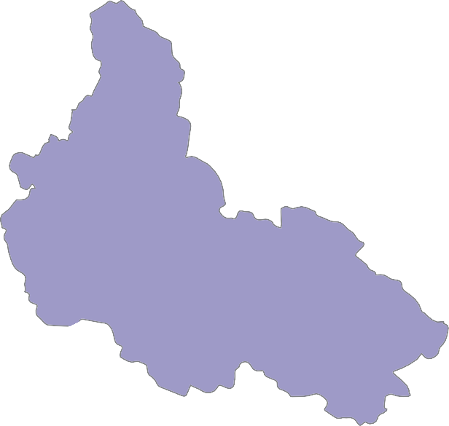



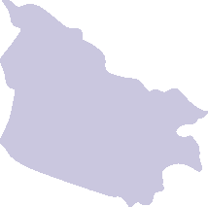
Key for the Map

Image for illustration only.
Insert the IPC map in small size without details on area labels.
IPC Chronic Food Insecurity Level Classification
(mapped Level represents highest severity affecting at least 20% of the population)

- - Minimal
- - Mild
- - Moderate
- - Severe
Areas with inadequate evidence Areas not analysed

Map Symbols
 Urban settlement classification

Recurrence of crisis - area classified as Crisis or worse during at least three years in the previous 10 years.
Evidence level:
* Acceptable
** Medium



*** High

IPC CHRONIC FOOD INSECURITY FOR MONTH YEAR

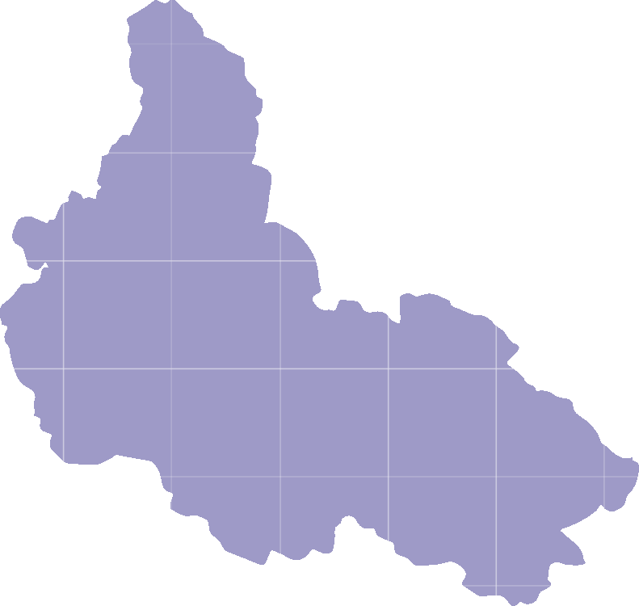
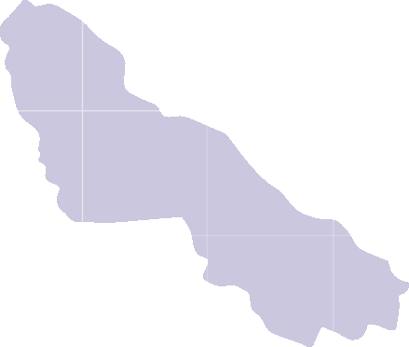
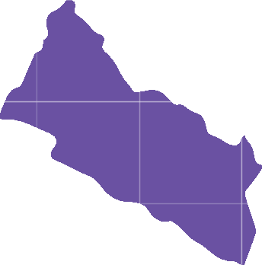

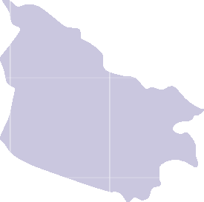
Key for the Map

Image for illustration only.
Insert and scale the size of the classification map developed according to the mapping protocols to fit the dedicated space in the module.
IPC Chronic Food Insecurity Level Classification
(mapped Level represents highest severity affecting at least 20% of the population)

1 - Minimal
2 - Mild
3 - Moderate
4 - Severe
Areas with inadequate evidence Areas not analysed
Map Symbols
 Urban settlement classification

Recurrence of crisis - area classified as Crisis or worse during at least three years in the previous 10 years.
Evidence level:

*
**
***
Acceptable Medium High

Population Table
Province | Total population | Level 1 |  | Level 2 |  | Level 3 |  | Level 4 |  | Level 3 +
Province | Total population | #people | % | #people | % | #people | % | #people | % | # | %
Province name | 000,000 | 00,000 | 00 | 00,000 | 00 | 00,000 | 00 | 00,000 | 00 | 00,000 | 00
Province name | 000,000 | 00,000 | 00 | 00,000 | 00 | 00,000 | 00 | 00,000 | 00 | 00,000 | 00
Province name | 000,000 | 00,000 | 00 | 00,000 | 00 | 00,000 | 00 | 00,000 | 00 | 00,000 | 00
Province name | 000,000 | 00,000 | 00 | 00,000 | 00 | 00,000 | 00 | 00,000 | 00 | 00,000 | 00
Province name | 000,000 | 00,000 | 00 | 00,000 | 00 | 00,000 | 00 | 00,000 | 00 | 00,000 | 00
Province name | 000,000 | 00,000 | 00 | 00,000 | 00 | 00,000 | 00 | 00,000 | 00 | 00,000 | 00
Province name | 000,000 | 00,000 | 00 | 00,000 | 00 | 00,000 | 00 | 00,000 | 00 | 00,000 | 00
Province name | 000,000 | 00,000 | 00 | 00,000 | 00 | 00,000 | 00 | 00,000 | 00 | 00,000 | 00
Province name | 000,000 | 00,000 | 00 | 00,000 | 00 | 00,000 | 00 | 00,000 | 00 | 00,000 | 00
Province name | 000,000 | 00,000 | 00 | 00,000 | 00 | 00,000 | 00 | 00,000 | 00 | 00,000 | 00
Grand Total | 0,000,000 | 0,000,000 | 00 | 000,000 | 00 | 000,000 | 00 | 000,000 | 00 | 0,000,000 | 00
Include number and percentage of people in each Level and specify the Level classification for each area. Aggregate findings at the most suitable administrative subdivision, bearing in mind that the table should not exceed 10 areas. Ensure overall population totals align and are consistent with aggregate table presented in Modules 1, 5 and 7.

SITUATION OVERVIEW AND KEY DRIVERS

Classification results
- Context, including relevant historical information and trends;
- Where, how many and how severe, focusing on worst affected areas and population figures;
- Current conditions, with references to food security outcomes (food consumption quality and quantity and nutritional status);
- Who, providing general socio-economic characteristics of the most food-insecure, including gender disparities if possible.

Limiting and underlying factors driving Chronic Food Insecurity
Provide a description of the following issues:
- Identify vulnerabilities contributing to the situation and the most limiting dimensions (food availability, access, utilization or stability);
- Highlight the direct or proximate factors driving food insecurity, trying also to emphasize where and why these are prevalent;
- Break down major factors – explain the actual problems and related major indicators/aspects, e.g. relating to quality and quantity of diet, livelihood strategies, and resilience to shocks.

Outcomes of Chronic Food Insecurity
Provide a description of the main outcomes, including food consumption and nutrition levels.

RECOMMENDATIONS FOR ACTION

Response Priorities
Identify population in need of different strategic actions. Refer to the Priority Response Objectives of the relevant Levels as detailed in the Reference Table. Defining specific modalities of response is not required and usually not possible at this stage of situation analysis.s

Situation Monitoring and Update
- Identify IPC Analysis and other plans to monitor the situation.
- Identify recommendations for data collection and information systems, i.e. timing, coverage and indicators as relevant to fill the data quality and quantity gaps faced during the analysis.

DETAILED POPULATION TABLE

Insert a brief methodological note on how the populations were estimated. Focus should be on the evidence-based consensus- building nature of the method, where prevalence of direct (and indirect) evidence is used to estimate the likely distribution of people between the four severity levels.

Province | District | Total population | Level 1 |  | Level 2 |  | Level 3 |  | Level 4 |  | District level | Level 3 +
Province | District | Total population | #people | % | #people | % | #people | % | #people | % | District level | # | %
Province | District name | 000,000 | 00,000 | 00 | 00,000 | 00 | 00,000 | 00 | 00,000 | 00 | # | 00,000 | 00
Province | District name | 000,000 | 00,000 | 00 | 00,000 | 00 | 00,000 | 00 | 00,000 | 00 | # | 00,000 | 00
Province | District name | 000,000 | 00,000 | 00 | 00,000 | 00 | 00,000 | 00 | 00,000 | 00 | # | 00,000 | 00
Province | District name | 000,000 | 00,000 | 00 | 00,000 | 00 | 00,000 | 00 | 00,000 | 00 | # | 00,000 | 00
Province | District name | 000,000 | 00,000 | 00 | 00,000 | 00 | 00,000 | 00 | 00,000 | 00 | # | 00,000 | 00
Province | District name | 000,000 | 00,000 | 00 | 00,000 | 00 | 00,000 | 00 | 00,000 | 00 | # | 00,000 | 00
Province | District name | 000,000 | 00,000 | 00 | 00,000 | 00 | 00,000 | 00 | 00,000 | 00 | # | 00,000 | 00
Province | District name | 000,000 | 00,000 | 00 | 00,000 | 00 | 00,000 | 00 | 00,000 | 00 | # | 00,000 | 00
Province | District name | 000,000 | 00,000 | 00 | 00,000 | 00 | 00,000 | 00 | 00,000 | 00 | # | 00,000 | 00
Province | Total | 0,000,000 | 000,000 | 00 | 000,000 | 00 | 000,000 | 00 | 000,000 | 00 |  | 000,000 | 00
Province | District name | 000,000 | 00,000 | 00 | 00,000 | 00 | 00,000 | 00 | 00,000 | 00 | # | 00,000 | 00
Province | District name | 000,000 | 00,000 | 00 | 00,000 | 00 | 00,000 | 00 | 00,000 | 00 | # | 00,000 | 00
Province | District name | 000,000 | 00,000 | 00 | 00,000 | 00 | 00,000 | 00 | 00,000 | 00 | # | 00,000 | 00
Province | District name | 000,000 | 00,000 | 00 | 00,000 | 00 | 00,000 | 00 | 00,000 | 00 | # | 00,000 | 00
Province | District name | 000,000 | 00,000 | 00 | 00,000 | 00 | 00,000 | 00 | 00,000 | 00 | # | 00,000 | 00
Province | District name | 000,000 | 00,000 | 00 | 00,000 | 00 | 00,000 | 00 | 00,000 | 00 | # | 00,000 | 00
Province | District name | 000,000 | 00,000 | 00 | 00,000 | 00 | 00,000 | 00 | 00,000 | 00 | # | 00,000 | 00
Province | Total | 000,000 | 000,000 | 00 | 000,000 | 00 | 000,000 | 00 | 000,000 | 00 |  | 000,000 | 00
Province | District name | 000,000 | 00,000 | 00 | 00,000 | 00 | 00,000 | 00 | 00,000 | 00 | # | 00,000 | 00
Province | District name | 000,000 | 00,000 | 00 | 00,000 | 00 | 00,000 | 00 | 00,000 | 00 | # | 00,000 | 00
Province | District name | 000,000 | 00,000 | 00 | 00,000 | 00 | 00,000 | 00 | 00,000 | 00 | # | 00,000 | 00
Province | District name | 000,000 | 00,000 | 00 | 00,000 | 00 | 00,000 | 00 | 00,000 | 00 | # | 00,000 | 00
Province | District name | 000,000 | 00,000 | 00 | 00,000 | 00 | 00,000 | 00 | 00,000 | 00 | # | 00,000 | 00
Province | District name | 000,000 | 00,000 | 00 | 00,000 | 00 | 00,000 | 00 | 00,000 | 00 | # | 00,000 | 00
Province | District name | 000,000 | 00,000 | 00 | 00,000 | 00 | 00,000 | 00 | 00,000 | 00 | # | 00,000 | 00
Province | District name | 000,000 | 00,000 | 00 | 00,000 | 00 | 00,000 | 00 | 00,000 | 00 | # | 00,000 | 00
Province | Total | 0,000,000 | 000,000 | 00 | 000,000 | 00 | 000,000 | 00 | 000,000 | 00 |  | 000,000 | 00
 | Grand Total | 0,000,000 | 0,000,000 | 00 | 000,000 | 00 | 000,000 | 00 | 000,000 | 00 |  | 0,000,000 | 00

Image for illustration only.
Develop a detailed population table merging findings of all areas analysed and disaggregated at relevant administrative level or other unit used in the analysis. Include total population, number and percentage of people in different Levels and the aggregate number and percentage of people in Levels 3 and 4 for each area. The calculation of percentage in each Level should be done in relation to population analysed. Specify the area Level classification for each area analysed.

PROCESS AND METHODOLOGY

Process and Methodology
- Detail the analysis process, including reference to the National TWG, identification of institutional arrangements, training, and activities undertaken before, during and after analysis.

Sources
- Include a list of main data sources used and a statement on evidence reliability.

Limitations of the analysis
- Identify limitations of the analysis, including technical and process challenges, such as evidence gaps, institutional arrangements, and participation.
What is the IPC and IPC Acute Food Insecurity?
The IPC is a set of tools and procedures to classify the severity and characteristics of acute food and nutrition crises as well as chronic food insecurity based on international standards. The IPC consists of four mutually reinforcing functions, each with a set of specific protocols (tools and procedures). The core IPC parameters include consensus building, convergence of evidence, accountability, transparency and comparability. The IPC analysis aims at informing emergency response as well as medium and long-term food security policy and programming.
For the IPC, Chronic Food Insecurity is defined as a manifestation of inadequate food and nutrient consumption over longer periods of time, mainly due to structural causes. This persistence is determined based on an analysis of conditions under non-exceptional circumstances. It changes slowly, happens gradually and does not usually pose an immediate threat to life, but may have severe consequences in terms of increased vulnerability and long-term negative impacts on health, physical, mental and cognitive capacities.

Chronic Food Insecurity Level name and description
Level 1 - No/Minimal Chronic Food Insecurity | Level 2 – Mild Chronic Food Insecurity | Level 3 – Moderate Chronic Food Insecurity | Level 4 – Severe Chronic Food Insecurity
In a common year, households are continuously able to access and consume a diet of acceptable quantity and quality for an active and healthy life. Household livelihoods are sustainable and resilient to shocks.  Households are not likely to have stunted children. | In a common year, households are able to access a diet of adequate quantity but do not always consume a diet  of adequate quality. Household livelihoods are borderline sustainable, and resilience to shocks  is limited. Households are not likely to have stunted children. | In a common year, households have ongoing mild deficits in food quantity and/or seasonal food quantity deficits  for 2 to 4 months of the year, and consistently do not consume a diet of adequate quality.  Household livelihoods are marginally sustainable, and their resilience to shocks is very limited.  Households are likely to have moderately stunted children. | In a common year, households have seasonal deficits in quantity of food for more than 4 months of the year and consistently do not consume a diet  of adequate quality. Household livelihoods are very marginal and are not resilient. Households are likely to have severely stunted children.

IPC Analysis Partners:
Contact for further Information
Surname, Name IPC function email@email.com
IPC Global Support Unit www.ipcinfo.org
This analysis has been conducted under the patronage of the ………(e.g. Ministry of Agriculture). It has benefited from the technical and financial support of …….(e.g. European Commission, UK Government).
Classification of food insecurity and malnutrition was conducted using the IPC protocols, which are developed and implemented worldwide by the IPC Global Partnership - Action Against Hunger, CARE, CILSS, EC-JRC, FAO, FEWS NET, Global Food
Security Cluster, Global Nutrition Cluster, IFPRI, IGAD, Oxfam, SICA, SADC, Save the
Children, UNDP, UNICEF, WFP, WHO and the World Bank.

SNAPSHOT



## M
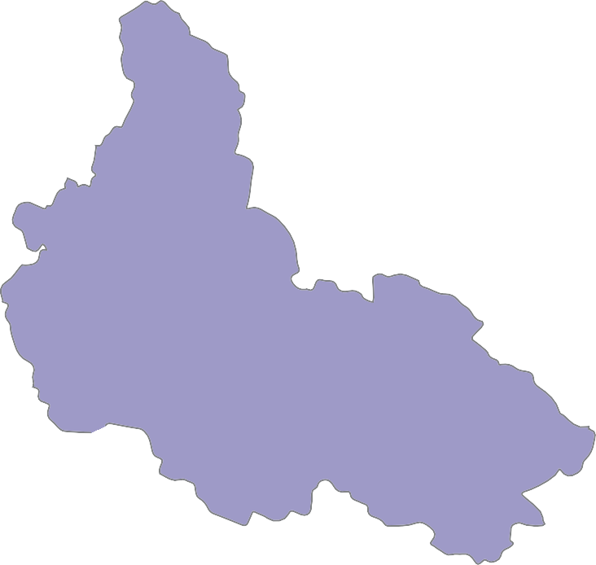




People Facing Severe and Moderate Chronic Food Insecurity
Key for the Map
IPC Chronic Food Insecurity Level Classification
(mapped Level represents highest severity affecting at least 20% of the population)
Image for illustration only.
Insert and scale the IPC map.
- - Minimal
- - Mild
- - Moderate
- - Severe
Areas with inadequate evidence Areas not analysed
Map Symbols
Urban settlement classification

Recurrence of crisis - area classified as Crisis or worse during at least three years in the previous 10 years.
Evidence level:
* Acceptable
** Medium
*** High

IPC Chronic 3+

## M
Total Population
38%
15%
3.31
00%
00%
Develop a pie chart to represent the percentage of analysed population in each Level.

- - Minimal
35%
22%
00%
_{00%} 00.0M
Population
- - Mild
- - Moderate
- - Severe

the most affected areas, aggregate findings at the gion
t suitable administrative subdivision, bearing in

population in Levels 3 and 4.
000,000
000,000
,000
000,
000,000
000,000
000,000
000,000
,000
mind that the layout can accommodate a maximum of 10 main areas. For each area, provide the number of
000,
000,000
000,000
Region
Region
For mos
Regi
Region
Region
PEOPLE MOST AFFECTED PER REGION (IPC Levels 4 and 3)

00%
on Region Region Region Region Re

000 000,000 000,000 000,000 000,000 000
000 000,000 000,000 000,000 000,000 000









of the total population need urgent action addressing chronic food insecurity
Food Access Limited in 00 Areas
NUTRITIONAL STATUS
00%
PEOPLE FACING HIGH LEVEL OF POVERTY
00%
POPULATION WITH LIMITED SUSTAINABLE LIVELIHOOD STRATEGIES
00%
Low income and purchasing power
000,000
People at Minimal Level
Lack of access to productive assets
Vulnerability to shocks
Decide on the most important outcomes to highlight in the infographic (quality of food consumption, quantity of food consumption, nutrition status) through number(s) and icon(s).

Decide on four to six key underlying factors to highlight in the infographic, write them and add the appropriate icons/images as well as any numbers/figures if available.
000,000
People at Mild Level
000,000
People at Moderate Level
KEY DRIVERS IN LEVEL 4 AREAS
Limited access to social services
Children under 5 years of age chronically malnourished
000,000
People at Severe Level
MAJOR LIMITING FACTORS |  |  |  | MAJOR OUTCOMES IN LEVEL 4 AREAS
Food Availability | Limited in | 00 | Areas | INADEQUATE FOOD CONSUMPTION
Indicate in access and foo | how many area d utilization ar | s food a e limiting | vailability, food factors. | 00%  people | Insufficient food quantity
Food Utilization | Issues in | 00 | Areas | 00%  people | Insufficient food quality

MAJOR LIMITING FACTORS AND KEY DRIVERS MATRIX

OVERVIEW OF THE MAJOR LIMITING FACTORS AND KEY DRIVERS BY ANALYSIS UNIT
ANALYSIS UNIT | LIMITING FACTORS  OF FOOD INSECURITY |  |  | KEY DRIVERS  OF FOOD INSECURITY
ANALYSIS UNIT |  |  |  |  |  |  |  |  |  |  |  |  |   ! | 
ANALYSIS UNIT | Food Availability | Food Access | Food Utilization | Livelihood Strategies | Human Capitals | Physical Capitals |  |  | Financial Capitals | Natural Capitals | Social Capitals | Policy/ Institutional Processes | Recurrent Risks | Unusual Crises
Name
Name
Name
Name
Name
Name
Name
Name
Name
Name
Legend |  | Major Factor |  |  | Minor Factor |  |  |  |  | Not a Factor |  |  | No Data

Use the table provided in the module to indicate the major limiting factors, key drivers as well as no data availability per area. Use ISS to complete the table.

PROFILE OF THE MOST AFFECTED AREAS

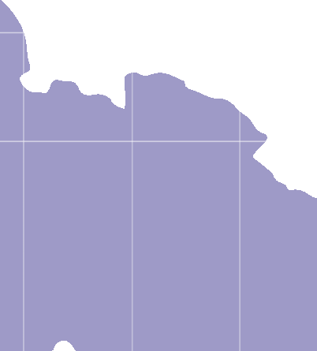




Name of the Affected Area/Group

Image for illustration only.
Develop or cut portion of the IPC map(s), focusing on the area/group.

Key for the Map
IPC Chronic Food Insecurity Level Classification
 1 - Minimal
 2 - Mild
 3 - Moderate
4 - Severe
 Areas with inadequate evidence Areas not analysed

Provide an overview of situation in the area/group including reference to evidence and attempting to answer the five key questions (how severe, how many, why, who and where), and recurrence of crisis. Provide recommendations for action as relevant.
How Severe?
How Many?
Why?
Who?
Where?

(‘000s)
MAJOR LIMITING FACTORS
000,000

000,000

000,000

000,000
00
Severe
00
Moderate
00
Mild
00
Minimal
KEY DRIVERS
%
IPC CFI LEVEL

Fill out the table with population estimates in the different IPC Levels for that area/group and insert icons representing two to four key limiting factors and drivers for that area/group.

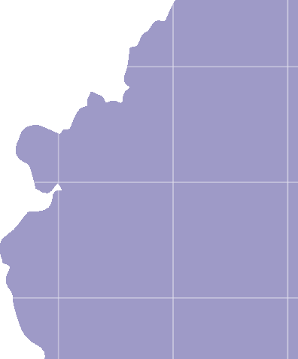


Name of the Affected Area/Group

Image for illustration only.
Develop or cut portion of the IPC map(s), focusing on the area/group.

Key for the Map
IPC Chronic Food Insecurity Level Classification
1 - Minimal
2 - Mild
3 - Moderate
4 - Severe
Areas with inadequate evidence Areas not analysed

Provide an overview of situation in the area/group including reference to evidence and attempting to answer the five key questions (how severe, how many, why, who and where), and recurrence of crisis. Provide recommendations for action as relevant.
How Severe?
How Many?
Why?
Who?
Where?

IPC CFI LEVEL | % | (‘000s) | MAJOR LIMITING FACTORS | KEY DRIVERS
Minimal | 00 | 000,000
Minimal | 00 | 000,000 | Fill out the table with population estimates in the different IPC Levels for that area/group and insert icons representing two to four key limiting factors and drivers for that area/group.
Mild | 00 | 000,000
Moderate | 00 | 000,000
Severe | 00 | 000,000

